Server Deployment Package
User Guide (for Windows Version)
Perforce Software, Inc.
Preface
This guide tells you how to set up a new Perforce installation using the Server Deployment Package (SDP). Recommendations for optimal system maintenance and performance are included as well. The SDP follows best practices for Perforce server configuration and administration. It consists of standard configuration settings, scripts, and tools, which provide several key features.
- A volume layout designed for maximum data integrity and server performance.
- Automated offline checkpointing and backup procedures for server metadata.
- Replication to another server.
- Easy maintenance of user accounts, labels, workspaces, and other data.
- User authentication using LDAP or Active Directory.
This guide assumes some familiarity with Perforce, and does not duplicate the basic information in the Perforce user documentation. For basic information on Perforce, consult Introducing Perforce. For system administrators, the Perforce System Administrator’s Guide is essential reading. All documentation is available from the Perforce web site at http://www.perforce.com.
Please Give Us Feedback
Perforce welcomes feedback from our users. Please send any suggestions for improving this document or the SDP to consulting@perforce.com.

Overview 1
Configuring the Perforce Server 2
Volume Layout and Hardware 2
Instance Names 5
Memory and CPU 6
General SDP Usage 6
Monitoring SDP activities 7
Installing the Perforce Server and the SDP 8
Clean Installation 8
Pre-requisites 9
Configuring Powershell 9
Initial setup 10
Running Configuration script 10
Installing service(s) 11
Start the server to test 11
Applying configurables to the server instance 12
Configuring the server 12
Verifying your server installation 13
Scheduling maintenance scripts 13
Setup the review script 15
Saving your configuration files in Perforce 15
Archiving configuration files 16
Configuring a New Instance on an existing machine 16
Upgrading an existing (non SDP) Windows installation 16
Upgrading an older Windows SDP installation 17
Configuring protections, file types, monitoring and security 18
Backup, Replication, and Recovery 19
Typical Backup Procedure 19
Full One-Way Replication 20
Replication Setup 21
Recovery Procedures 22
Recovering from a checkpoint and journal(s) 23
Recovering from a tape backup 23
Failover to a replicated standby machine 24
Server Maintenance 24
Server upgrades 24
Database Modifications 25
Listing inactive specifications 25
Unloading and Reloading labels 25
Archiving client workspaces and branch specifications 27
Deleting users 27
Listing users 27
Group management 27
Adding users 27
Email functions 28
Workspace management 28
Removing empty changelists 28
Maximizing Server Performance 29
Optimizing the database files 29
To minimize the size of back up files and maximize server performance, minimize the size of the db.have and db.label files. The scripts described in Unloading and Reloading labels, Deleting users, and Unloading and Reloading labels 29
Managing server load 30
Limiting large requests 30
Offloading remote syncs 31
P4V performance settings 31
Tools and Scripts 32
Standard scripts 32
Daily-backup 32
live-checkpoint 33
p4review.py 33
p4verify 33
p4verify-incremental 33
create-offline-db-from-checkpoint 33
P4login 34
totalusers.py 34
remove_jobs.py 34
p4lock.py and p4unlock.py 34
isitalabel.py 34
email_pending_user_deletes.py and email_pending_client_deletes.py 34
delclients.py 34
del_shelve.py 35
countrevs.py 35
Maintain_user_from_groups.py 35
instsrv.exe 35
prepckp.py 35
srvany.exe 35
Other Files 35
Appendix A – Frequently Asked Questions 37
Journal out of sequence 37

Overview
The SDP has four main components:
- Hardware and storage/filesystem layout recommendations for Perforce.
- Scripts to automate offline checkpoints and other critical maintenance activities.
- Scripts to replicate the Perforce journal to another volume or server.
- Scripts to assist with user account maintenance and other routine administration tasks.
Each of these components is covered in detail in this guide.
We expect you to check the SDP into a depot called Perforce as part of the installation process. The directory structure of the SDP is shown below in Figure 1: SDP Directory Structure.

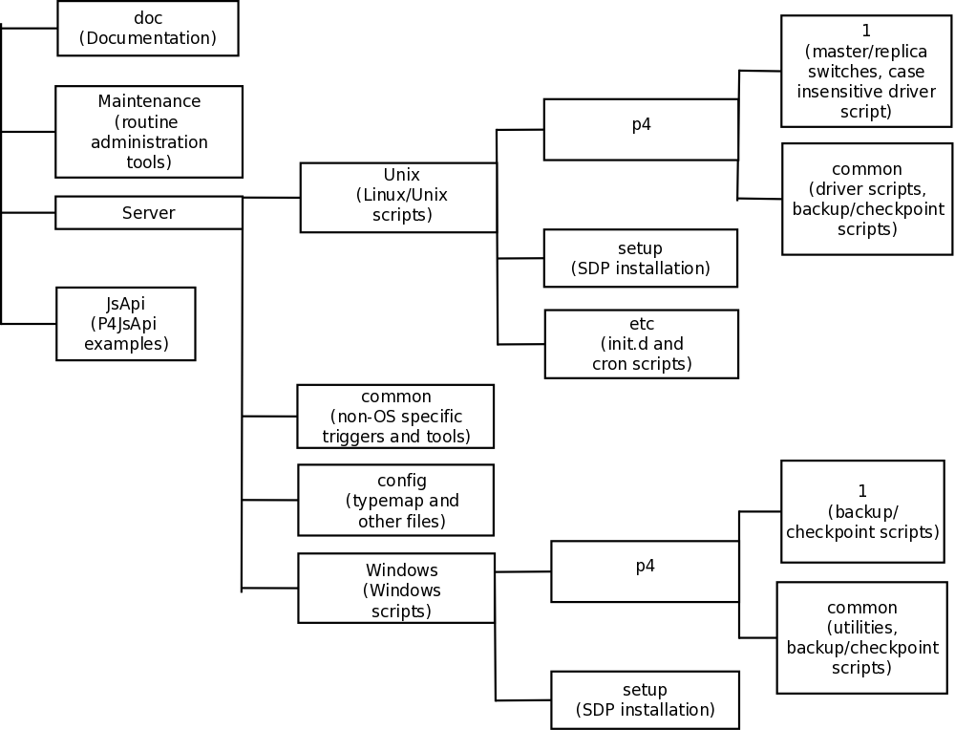
Figure 1: SDP Directory Structure

Configuring the Perforce Server
This chapter tells you how to configure a Perforce server machine and an instance of the Perforce Server. These topics are covered more fully in the System Administrator’s Guide and in the Knowledge Base; this chapter covers the details most relevant to the SDP.
The SDP can be installed on multiple server machines, and each server machine can host one or more Perforce server instances. (In this guide, the term server refers to a Perforce server instance unless otherwise specified.) Each server instance is assigned a number. This guide uses instance number 1 in the example commands and procedures. Other instance numbers can be substituted as required.
This chapter also describes the general usage of SDP scripts and tools.

Volume Layout and Hardware
To ensure maximum data integrity and performance, use three different physical volumes for each server instance. Three volumes can be used for all instances hosted on one server machine, but using three volumes per instance reduces the chance of hardware failure affecting more than one instance. It is possible but not recommended to put all the files onto a single physical volume.
- Perforce metadata (database files): Use the fastest volume possible, ideally RAID 1+0 on a dedicated controller with the maximum cache available on it. This volume is normally called /metadata.
- Journals and logs: Use a fast volume, ideally RAID 1+0 on its own controller with the standard amount of cache on it. This volume is normally called /logs. If a separate logs volume is not available, put the logs on the depotdata volume.
- Depot data, archive files, scripts, and checkpoints: Use a large volume, with RAID 5 on its own controller with a standard amount of cache or a SAN or NAS volume. This volume is the only volume that must be backed up. The backup scripts place the metadata snapshots on this volume. This volume can be backed up to tape or another long term backup device. This volume is normally called /depotdata.

If three controllers are not available, put the logs and depotdata volumes on the same controller. Do not run anti-virus tools or back up tools against the metadata volume(s) or logs volume(s), because they can interfere with the operation of the Perforce server.
Back up everything on the depotdata volume(s). Avoid backing up the metadata volume directly, because doing so can interfere with the operation of a live Perforce server, potentially corrupting data. The checkpoint and journal process archive the metadata on the depotdata volume. Backing up the logs volume is optional.

The SDP assumes (but does not require) the three volumes described above.

View Figure 2: Volume Layout (below), viewed from the top down, displays a Perforce application administrator’s view of the system, which shows how to navigate the directory structure to find databases, log files, and versioned files in the depots. Viewed from the bottom up, it displays a Perforce system administrator’s view, emphasizing the physical volume where Perforce data is stored.
Both Unix and Windows installation of the SDP now use symlinks (on Windows this is via the mklink tool).

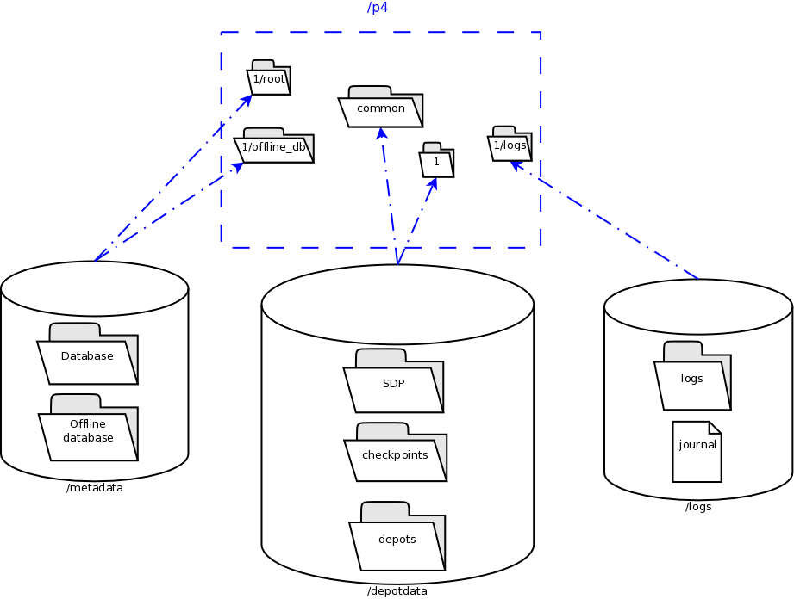
Figure 2: Volume Layout

F:\depotdata/p4/1/bin
F:\depotdata\p4\1\checkpoints
F:\depotdata\p4\1\depots
F:\depotdata\p4\1\ssl
F:\depotdata\p4\1\tmp
F:\depotdata\p4\common
F:\depotdata\p4\config

M:\metadata\p4\1\offline_db
M:\metadata\p4\1\root
J:\logs\p4\1\logs

C:\p4\1
bin
checkpoints
depots
ssl
tmp
offlin_db
root
logs
C:\p4\common
C:\p4\config

Figure 3: Logical and Physical View Mapping
The links are shown as <SYMLINKD> below on a Windows installation.
Directory of c:\p4
20/06/2014 15:05 <DIR> .
20/06/2014 15:05 <DIR> ..
20/06/2014 15:05 <SYMLINKD> common [f:\p4\common]
20/06/2014 15:05 <SYMLINKD> config [f:\p4\config]
20/06/2014 15:05 <SYMLINKD> M1 [f:\p4\M1]

Directory of c:\p4\M1
20/06/2014 15:05 <DIR> .
20/06/2014 15:05 <DIR> ..
20/06/2014 15:05 <DIR> bin
20/06/2014 15:05 <DIR> checkpoints
20/06/2014 15:05 <DIR> depots
20/06/2014 15:05 <SYMLINKD> logs [g:\p4\M1\logs]
20/06/2014 15:05 <SYMLINKD> offline_db [e:\p4\M1\offline_db]
20/06/2014 15:05 <SYMLINKD> root [e:\p4\M1\root]
20/06/2014 15:05 <DIR> ssl
20/06/2014 15:05 <DIR> tmp

Instance Names
Traditionally the SDP has used integers for instance names which show up in the paths above, for example C:\p4\1\root.
However it is increasingly the case that alphanumeric names are used for instances, e.g. C:\p4\Acme\root. Commonly organizations strive to use a single Perforce instance, one logical data set, which may be replicated around the globe. Using a single instance optimize colloboration and simplifies code access for all development activity. When there is a single instance, the name ‘1’ is as good as any. When there is more than one instance, e.g. if there are isolated silos of development activity, an alaphnumeric name may be more helpful than an integer for identifying the data set, such as Acme or perhaps LegacyApps. Another instance is sometimes to develop and test things like Perforce trigger scripts before rolling them out to the live production instance, or to provide a standing internal training data set.
In any case it is worth thinking and planning your naming, particularly if you have multiple instances including replicas of different types and these are located on different hosts.
If you are using instance numbers, then an example configuration where there are 2 master server instances, each with a replica, might be:
Server hostname | Instance ID | Port
p4d-sfo-01 | 1 | 1666
sfo-p4d-01 | 2 | 2666
sfo-p4d-02 | 1 | 1666
sfo-p4d-02 | 2 | 2666
For consistency, instances with same ID should refer to the same logical data set, they just run on different machines.
Alternatively, alphanumeric names can be clearer and easier:
Server hostname | Instance ID | Port
sfo-p4d-01 | Acme | 5000
sfo-p4d-01 | Test | 5999
sfo-p4d-02 | Acme | 5000
sfo-p4d-02 | Test | 5999
Some sites apply a convention to the port number to identify whether the P4PORT value is that of a master server, a broker, replica, edge server, or proxy. In such cases the first digit is reserved to identify the instance, and the remaining 3 digits identify the target service, e.g. 666 for a broker, 999 for a master server, 668 for a proxy.
Host naming conventions vary from site to site, and often have local naming preferences or constraints. These examples the the code of the nearest major airport, sfo in this case, as a location code. Using location in the hostname is merely an example of a site preference, not necessarily a best practice.
End user P4PORT values typically do not reference the actual machine names. Instead they reference an alias, e.g. perforce or sfo-p4d (without the -01). This helps make failover operations more transparent.

Memory and CPU
Maximum performance is obtained if the server has enough memory to keep all of the database files in memory. Make sure the server has enough memory to cache the db.rev database file and to prevent the server from paging during user queries.
Below are some approximate guidelines for allocating memory.
- 1.5 kilobyte of RAM per file stored in the server.
- 32 MB of RAM per user.
Use the fastest processors available with the fastest available bus speed. Faster processors with a lower number of cores provide better performance for Perforce. Quick bursts of computational speed are more important to Perforce's performance than the number of processors, but have a minimum of two processors so that the offline checkpoint and back up processes do not interfere with your Perforce server.

General SDP Usage
This section presents an overview of the SDP scripts and tools. Details about the specific scripts are provided in later sections.
Most tools reside in c:\p4\common\bin. The directory c:\p4\instance\bin contains scripts and executables that are specific to a server instance, such as the p4.exe client. The scripts in c:\p4\instance\bin generally set the environment for an instance correctly, then invoke the corresponding script in c:\p4\common\bin.
Run important administrative commands using the scripts in c:\p4\instance\bin, when available. When issuing a Perforce command directly on the server machine, set the environment by invoking c:\p4\common\bin\p4env.bat or by working in a properly configured workspace. Then, use the p4.exe executable located in c:\p4\instance\bin.
Below are some usage examples for instance 1 or instance master.

Example | Remarks
c:\p4\common\bin\p4env.bat 1  c:\p4\1\bin\p4 admin stop | Run p4 admin stop on instance 1
c:\p4\common\bin\live_checkpoint.bat 1 | Take a checkpoint of the live database on instance 1
c:\p4\master\bin\daily_checkpoint.bat | A daily checkpoint of the master instance.

Monitoring SDP activities
The important SDP maintenance and backup scripts generate email notifications when they complete.
For further monitoring, you can consider options such as:
- Making the SDP log files available via a password protected HTTP server.
- Directing the SDP notification emails to an automated system that interprets the logs.

Installing the Perforce Server and the SDP
This chapter tells you how to install a Perforce server instance in the SDP framework. For more details about server installation, refer to the Perforce System Administrator’s Guide.
Many companies use a single Perforce Server to manage their files, while others use multiple servers. The choice depends on network topology, the geographic distribution of work, and the relationships among the files being managed. If multiple servers are run, assign each instance a number and use that number as part of the name assigned to depots, to make the relationship of depots and servers obvious. See the discussion above on Instance Names.
To install the SDP, you must have Administrator access to the Windows server machine(s) as you will be installing services.

Clean Installation
In this section we describe the server and SDP installation process on Windows. The process consists of:
- Initial setup of the file system and configuration files.
- Running the SDP configuration script.
- Starting the server and performing initial configuration.
Do not use the Windows installer to install and configure the Perforce server. It will configure the environment for a single Perforce server.

Pre-requisites
The following is required (details mentioned below):
- Administrator account on the server
- Python installed (see below)
- Perforce Helix executables (p4/p4d – see below)
- Powershell 2.x or greater
Optional (but recommended):
- Perforce Helix Visual client (P4V – optional but very useful)
- An editor (Notepad will do, but Download Notepad++)
- GOW (Gnu on Windows) – optional but very useful for parsing log files etc.

Configuring Powershell
The scripts now use Powershell rather than .BAT files due to improved error handling and options, and code re-use (via a single included module rather than duplication of functionality in every script). This also allows us to keep the scripts more closely aligned with the functionality of the Unix scripts.
It is important to enable local scripts to be run. The following command must be run within an Powershell Administrator prompt:
For Windows 7, Windows 8, Windows Server 2008 R2 or Windows Server 2012, run the following commands as Administrator:
x86
Open C:\Windows\SysWOW64\cmd.exe
Run the command powershell Set-ExecutionPolicy RemoteSigned
x64
Open C:\Windows\system32\cmd.exe
Run the command powershell Set-ExecutionPolicy RemoteSigned
You may need to ensure that the various scripts are not “blocked” – right click in Windows Exploer and check Properties options.

Initial setup
Prior to installing the Perforce server, perform the following steps.
- Mount the volumes for the three-volume configuration described in Volume Layout and Hardware. The procedure assumes the drives are mapped as follows:
  - Metadata on e:
  - Depotdata on f:
  - Logs on g:
- Copy the SDP to the f:\sdp directory (%SDP%).
- Customize the following for your environment. It requires you to identify the master server and all replicas that we need to setup for the SDP, including instance names, hostnames, etc. This information is all in a single file:
  - %SDP%\Server\Windows\setup\sdp_master_config.ini
- Customize the following for your environment:
  - %SDP%\Server\Windows\p4\common\bin\run_p4review.cmd
- Download and install Python, e.g. from www.python.org. We use Python 2.7.x (latest) and 3.4.x (latest). Usually we will install 32 bit even on 64 bit OS for ease of compilation of extras, but it is your choice. Typically we install to default dir, e.g. c:\python27. For initial installation we only require base Python. For subsequent scripting you may wish to install P4Python (e.g. using pip).
- Other tools we find useful: Notepad++ and GOW (Gnu on Windows - Unix command line utilities such as wc, head, tail). These are optional

- Download to directory %SDP%\Server\Windows\setup the following files:
  - The desired release of Windows of p4.exe and p4d.exe, e.g. for release 15.1 and 64 bit Windows:
ftp://perforce/r15.1/bin.ntx64/p4d.exe
ftp://perforce/r15.1/bin.ntx64/p4.exe
Substitute bin.ntx86 for 32 bit Windows (unusual these days).

Running Configuration script
The SDPEnv.py script, available in %SDP%\Server\Windows\setup, sets up the basic directory structure used by the SDP. It creates .bat files to register the Perforce service as Windows services. It parses and validates the sdp_master_config.ini file in the same directory.
You need to customize this sdp_master_config.ini file. It contains lots of comments as to how to set the various configuration values.
Review the contents of template_configure_new_server.bat file which defines the recommended default configurable values for any server, and make any desired changes. This file will be parsed and used to create instance specific configuration files.
After updating the configuration file, run SDPEnv.py from the same directory.
You must run this command from a CMD window which has administrator rights.
cd %SDP%\Server\Windows\setup
Edit and save changes:
notepad sdp_master_config.ini
Run the command to create the environment:
SDPEnv.py –c sdp_master_config.ini
If the output looks correct then re-run the script with –y parameter to actually perform the copying of files and creation of directories and links:
SDPEnv.py –c sdp_master_config.ini -y

Installing service(s)
The above command will create a couple of files in that directory. The first is install_services_<hostname>.bat, so on a machine where the hostname is svrp4master, it will be install_services_svrp4master.bat
Validate the contents of this file and run it if it looks appropriate – this installs the service(s) with appropriate parameters. Please note that it is specific to the hostname that you specified inside sdp_master_config.ini – so it will only run on the correct host server.
Note that if you have defined multiple instances in sdp_master_config.ini to run on this same hostname, then they will all be installed by this .bat file.

Start the server to test
Having installed the service, we now test that it will start: “net start p4_<instance name>”, e.g.
net start p4_1
Or
net start p4_Master
If the service fails to start, then examine the log file for the reasone (e.g. missing license file) in c:\p4\instance_name\logs.
Ensure the server is running (specify appropriate port):
p4 –p 1666 info
Use “net stop p4_<instance>” to stop the service if required.

Applying configurables to the server instance
For each instance defined in sdp_master_config.ini, a configuration .bat file will be created, called configure_<instance>.bat, so for instance master, it will be configure_master.bat.
Review the contents of the file and make any desired changes.
You will only be able to run the .bat file if you have started the server instance as per previous section.
If an instance is a replica (or similar), then you should apply the configurables to the master server and then checkpoint it before seeding the replica – see the Distributing Perforce guide.

Configuring the server
To configure the server, perform the following steps:
- Make sure your server is running (specify appropriate port below):
p4 –p 1666 info
- Create your Perforce administrator account within the Perforce repository, using the user name and password specified in sdp_master_config.ini.
- If you are using a Perforce server version 2013.3 or older, install the Depot Spec Map Field trigger in the trigger table as shown below. If you are using 2014.1 or newer, the server.depot.root configurable should be used in place of the trigger.
DepotSpecMapField form-out depot "c:\python27\python c:\p4\common\bin\triggers\SetDefaultDepotSpecMapField.py %formfile% Master f:"
- To create a Perforce depot called Perforce, issue the following command:
p4 depot Perforce
The depot specification is displayed in a text editor. The Map: field is populated by the depot map trigger.
- To create a Perforce spec depot, issue the following command:
p4 depot specs
The depot specification is displayed in a text editor. The Map: field is populated by the depot map trigger or by the configurable. Change the type to spec and save the form.
- To create an unload depot, issue the following command:
p4 depot unload
The depot specification is displayed in a text editor. The Map: field is populated by the depot map trigger. Change the type to unload and save the form.
- To delete the default Perforce depot, which is called depot, issue the following command: p4 depot -d depot. (If you prefer to keep the default depot, modify its map field so that it is stored on the depotdata volume.) Create one or more depots as required to store your files, following your site’s directory naming conventions.

Verifying your server installation
To verify your installation, perform these steps:
- Issue the p4 info command, after setting appropriate environment variables. If the server is running, it will display details about its settings.
- Create a client workspace and verify that it is archived in the spec depot and written to the c:\p4\Master\depots\specs\client directory.
- Add a file to the server and verify that the archive file gets created in the corresponding directory under c:\p4\Master\depots\Perforce.

Scheduling maintenance scripts
In Windows 2012 you should use the Task Scheduler. We recommend that you create a folder called Perforce at the top level in which to create your tasks (otherwise they can be hard to find when you next look in Task scheduler!).
Note that the “schtasks” command can be useful from command line, or “taskschd.msc” to get the control panel equivalent.
The recommendation is to run daily-backup.ps1 every day at say 2:00 am (or similar time).

Task Basics
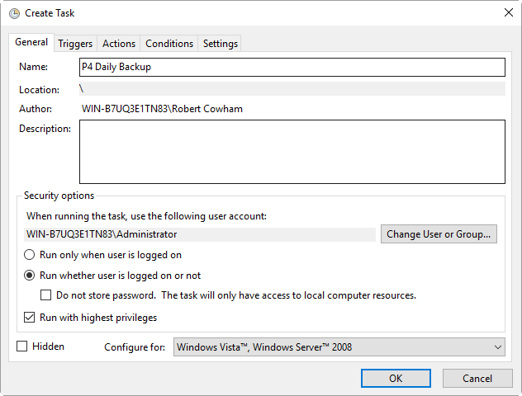

Trigger screen
Set the time to run like this:
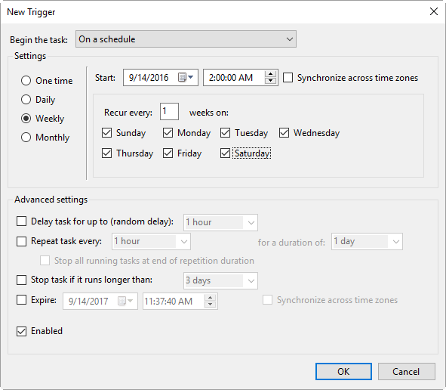

Action
Program: powershell
Arguments: -file c:\p4\common\bin\daily-backup.ps1 master
Where <master> is your instance name.
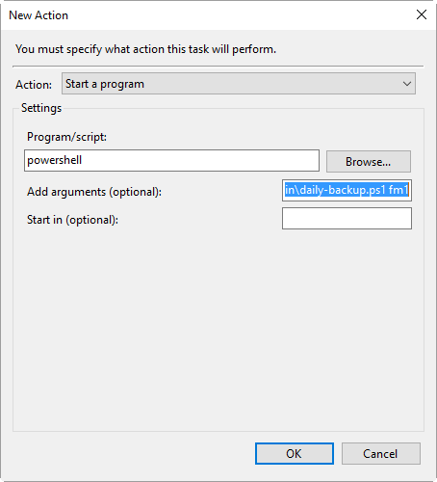

Setup the review script
Use Windows task scheduler to create a p4_Master_review task that runs once per day from 00:00 to 23:50 every 5 minutes. The task should run this command:
c:\p4\common\bin\run_p4review.cmd Master

Saving your configuration files in Perforce
It is sensible to create a Perforce workspace and to store the configuration files in Perforce.
Typically the depot root might be something like //perforce/sdp. If you have many machines, then you might use //perforce/sdp/<machine> using either a physical or a logical name for the machine.
A typical workspace view (e.g. for workspace called p4admin.sdp and for instance master), might be:
Root: c:\p4
View:
//perforce/sdp/p4/master/bin/... //p4admin.sdp/master/bin/...
//perforce/sdp/p4/common/bin/... //p4admin.sdp/common/bin/...
//perforce/sdp/p4/config/... //p4admin.sdp/config/...

You would have appropriate workspaces for each machine, and appropriate lines for each instance on that machine.

Archiving configuration files
Now that the server is running properly, copy the following configuration files to the depotdata volume for backup:
- The scheduler configuration.
- Cluster configuration scripts, failover scripts, and disk failover configuration files.

Configuring a New Instance on an existing machine
It is possible to add a new instance to an existing machine.
Edit the sdp_master_config.ini and add a new section for the new instance.
The run SDPEnv.py, specifying to just create the new instance.
cd %SDP%\Server\Windows\setup

notepad sdp_master_config.ini

SDPEnv.py –c sdp_master_config.ini --instance Replica2
If the output looks correct then re-run the script with –y parameter to actually perform the copying of files and creation of directories and links.

Upgrading an existing (non SDP) Windows installation
The easiest way to upgrade a service instance is:
- Create new sdp_master_config.ini file to describe the existing installations.
- Run SDPEnv.py to create the new environment – this is unlikely to
- Run install_services_<hostname>.bat to create new services.
  - Stop existing services
  - Manually move the following files from their existing to new locations:
    - db.* files
    - license
    - log file(s)
    - journal
    - checkpoints and archived journals
  - Start new service and check it runs successfully
  - Adjust the depot root paths (with 2014.1 or greater use the configurable server.depot.root, otherwise manually edit depot specs and install the appropriate trigger for new depot specs)
Simple reporting commands to compare before/after include:
- p4 changes –m20 –l –t > changes.txt
- p4 depots > depots.txt
- p4 verify –q //…@yyyy/mm/dd,#head (specifying a few days before the cutover)

Upgrading an older Windows SDP installation
Older versions of the Windows SDP (pre June 2014) stored configuration values for each instance in a p4env.bat file within the p4\common\bat directory.
They also didn’t link all directories from c:\p4, but instead used drives such as E:, F: and G: and paths on those drives.
The easiest way to upgrade (most of the work can be done without stopping the service) is:
- Ensure that existing instance files are checked in to Perforce (instance\bin and common\bin files), for example in workspace p4admin.sdp.orig (use a root directory of %DEPOTDATA% - see next step).
- Extract existing values from p4env.bat such as mailfrom, mailhost, mailto, and also METADATA, LOGDATA and DEPOTDATA
- Edit sdp_master_config.ini and set the appropriate values using extracted ones, and appropriate instance specific values.
- Set the values for METADATA_ROOT, DEPOTDATA_ROOT and LOGDATA_ROOT to the same (dummy) value, e.g. c:\p4assets
- Run SDPENV.py to generate the new structure.
- Manually edit c:\p4assets\p4\config\sdp_config.ini and set the ROOT values to the existing values taken from step 2.
- Using a different but similar workspace p4admin.sdp.new, which has a root directory of c:\p4, run “p4 sync –k”, then do a “p4 reconcile” to identify all the changed files – this will include most of the .bat files, but it shouldn’t include p4d.exe or p4s.exe as we are not updating these files.
- Submit the new changes.
- In workspace p4admin..sdp.orig, carefully check the updated files that need to be synced (recommend you review diffs one by one), and then sync them.
- Manually remove and recreate the links (using “del” and “mklink /d”) for directories under c:\p4 so that they point to the existing directories on e:, f: or g: (the original DEPOTDATA).
- Review existing configurables and adjust as appropriate.
- Setup the scheduled tasks for daily/weekly backup and verify as appropriate. Validate that the daily backup works (typically wait until the next day)
- At an appropriate point, stop the existing service, adjust the service paths to use the new paths starting from c:\p4.

Configuring protections, file types, monitoring and security
After the server is installed and configured, most sites will want to modify server permissions (protections) and security settings. Other common configuration steps include modifying the file type map and enabling process monitoring. To configure permissions, perform the following steps:
- To set up protections, issue the p4 protect command. The protections table is displayed.
- Delete the following line:
write user * * //depot/...
- Define protections for your server using groups. Perforce uses an inclusionary model. No access is given by default, you must specifically grant access to users/groups in the protections table. It is best for performance to grant users specific access to the areas of the depot that they need rather than granting everyone open access, and then trying to remove access via exclusionary mappings in the protect table even if that means you end up generating a larger protect table.
- To set the server’s default file types, run the p4 typemap command and define your typemap to override Perforce’s default behavior.
Add any file type entries that are specific to your site. Suggestions:
- For already-compressed file types (such as .zip, .gz, .avi, .gif), assign a file type of binary+Fl to prevent the server from attempting to compress them again before storing them.
- For regular binary files, add binary+l to make so that only one person at a time can check them out.
- A sample file is provided in $SDP/Server/config/typemap
- For large, generated text files (e.g. postscript files), assign the text+C file type, to avoid causing server memory issues.
- If authentication against LDAP or Active Directory is required, use the authentication script AD_auth.pl, available in $SDP/Server/common/p4/common/bin/triggers, as a starting point. (There is also a version of the script called AD_auth_debug.pl, which contains additional debugging information.)
There is also a PowerShell authentication script which may be easier to configure than the Perl one. This powershell script is in $SDP/Server/Windows/p4/common/bin/triggers/ad-auth-check.ps1
Note: Perforce provides most IT required password management practices internally. It is recommend to use internal passwords over LDAP/AD to avoid exposing LDAP/AD passwords to the Perforce admin via the auth trigger.

Backup, Replication, and Recovery
Perforce servers maintain metadata and versioned files. The metadata contains all the information about the files in the depots. Metadata resides in database (db.*) files in the server’s root directory (P4ROOT). The versioned files contain the file changes that have been submitted to the server. Versioned files reside on the depotdata volume.
This section assumes that you understand the basics of Perforce backup and recovery. For more information, consult the Perforce System Administrator’s Guide and the Knowledge Base articles about replication.

Typical Backup Procedure
The SDP’s maintenance scripts, run as cron tasks on Unix/Linux or as Windows scheduled tasks, periodically back up the metadata. The weekly sequence is described below.
Seven nights a week, perform the following tasks.
- Rotate/truncate the active journal.
- Replay the journal to the offline database. (Refer to Figure 2: Volume Layout for more information on the location of the live and offline databases.)
- Create a checkpoint from the offline database.
- Recreate the offline database from the last checkpoint.
Once a week, perform the following tasks.
- Verify all depots.
This normal maintenance procedure puts the checkpoints (metadata snapshots) on the depotdata volume, which contains the versioned files. Backing up the depotdata volume with a normal backup utility like robocopy or rsync provides you with all the data necessary to recreate the server.
To ensure that the backup does not interfere with the metadata backups (checkpoints), coordinate backup of the depotdata volume using the SDP maintenance scripts.
The preceding maintenance procedure minimizes server downtime, because checkpoints are created from offline or saved databases while the server is running.
With no additional configuration, the normal maintenance prevents loss of more than one day’s metadata changes. To provide an optimal Recovery Point Objective (RPO), the SDP provides additional tools for replication.
Be sure to back up the entire depotdata volume using a normal backup utility.

Full One-Way Replication
Perforce supports a full one-way replication of data from a master server to a replica, including versioned files. The p4 pull command is the replication mechanism, and a replica server can be configured to know it is a replica and use the replication command. The p4 pull mechanism requires very little configuration and no additional scripting.
To use full one-way replication, you must:
- Set configuration parameters in the Perforce database for each replica instance. The SDP startup scripts use the replica hostname as the identifying server name. The configuration includes defining the number of p4 pull workers, and can be set up such that versioned files are only replicated on demand.
- Configure a service user for replica authentication using p4 configure. Note that you will need to execute the p4 login command (against the master server) for this service user on the replica server.
- Initialize the replica. Configure the replica as a duplicate of the SDP, and initialize it with a checkpoint and depots from the master server.
- Start the replica and verify that it is operating correctly. Note that login commands are forwarded to the master server, so be sure to use p4 login -a.
Each of these steps is explained in detail in the server documentation.
As this replication mechanism is simple and effective, we recommend it as the preferred replication technique. Replica servers can also be configured to only contain metadata, which can be useful for reporting or offline checkpointing purposes.
If you wish to use the replica as a read-only server, you can use the P4Broker to direct read-only commands to the replica. Use of the broker may require use of a P4AUTH server for authentication.
Replication handles all server metadata and versioned file content, but not the SDP installation itself or other external scripts such as triggers. Use tools such as robocopy or rsync to replicate the rest of the depotdata volume.

Replication Setup
To configure a replica server, first configure a machine identical to the master server, then install the SDP on it to match the master server installation. We assume that there is a broker in use in this setup. The broker is listening on port 1666 and master server is on port 1667.
Note, it is required that you set P4TICKETS for the service and for the users on the machine to a common location for replication to work. To set this up, run the following on both the master and the replica:
p4 set -s P4TICKETS=c:\p4\1\p4tickets.txt
p4 set -S p4_1 P4TICKETS=c:\p4\1\p4tickets.txt
Once the machine and SDP install is in place, you need to configure the master server for replication. We will assume the following for the setup:
The replica name will be replica1, the service user name is replica1, and the master server’s name is master, and the metadata volume is e:, the depotdata volume is f:, and the logs volume is g:. You will run the following commands on the master server:
- p4 configure set P4TICKETS=c:\p4\1\p4tickets.txt
- p4 configure set replica1#P4PORT=1667
- p4 configure set replica1#P4TARGET=master:1667
- p4 configure set replica1#journalPrefix=c:\p4\1\checkpoints\p4_1
- p4 configure set replica1#server=3
- p4 configure set "replica1#startup.1=pull -i 1"
- p4 configure set "replica1#startup.2=pull -u -i 1"
- p4 configure set "replica1#startup.3=pull -u -i 1"
- p4 configure set "replica1#startup.4=pull -u -i 1"
- p4 configure set "replica1#startup.5=pull -u -i 1"
- p4 configure set "replica1#db.replication=readonly"
- p4 configure set "replica1#lbr.replication=readonly"
- p4 configure set replica1#serviceUser=replica1
The following commands will also need to be run:
- p4 user -f replica1 (You need to add the Type: service field to the user form before saving)
- p4 passwd replica1 (Set the service user’s password)
- p4 group service.g (Add the service user to the Users section and set the timeout to unlimited.)
- p4 protect (Give the replica1 user super user rights to //…)

Now that the setttings are in the master server, you need to create a checkpoint to seed the replica. Run:
c:\p4\commond\bin\daily-backup.ps1 1
When the checkpoint finishes, copy the checkpoint plus the versioned files over to the replica server. You can use xcopy or something like robocopy for this step.
xcopy c:\p4\1\checkpoints\p4_1.ckp.###.gz replica_f_drive:\p4\1\checkpoints
xcopy c:\p4\1\depots replica_f_drive:\p4\1\depots /S
(### is the checkpoint number created by the daily backup)
Once the copy finishes, go to the replica machine run the following:
- c:\p4\1\bin\p4d -r c:\p4\1\root -jr -z c:\p4\1\checkpoints\p4_1.ckp.###.gz
- c:\p4\1\bin\p4 -p master:1667 -u replica1 login (enter the service user’s password)
- net start p4_1
Now, you check the log on the master server (c:\p4\1\logs\log) to look for the rmt-Journal entries that show you the replication is running. If you see those entries, then you can make some changes on the master server, and then go to the replica server and check to see that they changes were replicated across. For example, you can submit a change to the master server, then go to the replica server and check to see that the change was replicated over to the replica by running p4 describe on the changelist against the replica server.
The final steps for setting up the replica server are to set up the task scheduler to run the replica sync scripts. This has to be done via task scheduler running as a regular AD user so that the scripts can access the network in order to get to the drives on the replica machine.
You need to configure a task to run c:\p4\1\bin\sync_replica.bat every day except the day that weekly_backup.bat runs on the master. (Normally Saturday) The task should be set up to run after the master server finishes running daily_backup.bat. Be sure to give it some buffer for the length of time it takes the master to run daily_backup.bat to grow over time.
Next configure a task to run c:\p4\1\bin\weekly_sync_replica.bat the same day as the master runs weekly_backup.bat again giving the master time to finish running weekly_backup.bat

Recovery Procedures
There are three scenarios that require you to recover server data:
Metadata | Depotdata | Action required
lost or corrupt | intact | Recover metadata as described below
Intact | lost or corrupt | Call Perforce Support
lost or corrupt | lost or corrupt | Recover metadata as described below.  Recover the depotdata volume using your normal backup utilities.
Restoring the metadata from a backup also optimizes the database files.

Recovering from a checkpoint and journal(s)
The checkpoint files are stored in the c:\p4\instance\checkpoints directory, and the most recent checkpoint is named p4_instance.ckp.number.gz. Recreating up-to-date database files requires the most recent checkpoint, from c:\p4\instance\checkpoints, and the journal file from c:\p4\instance\logs.
To recover the server database manually, perform the following steps from the root directory of the server (c:\p4\instance\root).
- Stop the Perforce Server by issuing the following command:
c:\p4\instance\bin\p4_1 admin stop
- Delete the old database files in c:\p4\instance\root\save directory (note there may not be any files there as they will typically be cleared out after successful completion of the previous invocation of the recovery process – see below).
- Move the live database files (db.*) to the save directory.
- Use the following command to restore from the most recent checkpoint.
c:\p4\instance\bin\p4d_instance -r c:\p4\instance\root -jr -z
c:\p4\instance\checkpoints\p4_instance.ckp.most recent_#.gz
- To replay the transactions that occurred after the checkpoint was created, issue the following command:
c:\p4\instance\bin\p4d_instance -r c:\p4\instance\root -jr
c:\p4\instance\logs\journal
- Restart your Perforce server.
If the Perforce service starts without errors, delete the old database files from c:\p4\instance\root\save.
If problems are reported when you attempt to recover from the most recent checkpoint, try recovering from the preceding checkpoint and journal. If you are successful, replay the subsequent journal. If the journals are corrupted, contact Perforce Technical Support. For full details about back up and recovery, refer to the Perforce System Administrator’s Guide.

Recovering from a tape backup
This section describes how to recover from a tape or other offline backup to a new server machine if the server machine fails. The tape backup for the server is made from the depotdata volume. The new server machine must have the same volume layout and user/group settings as the original server. In other words, the new server must be as identical as possible to the server that failed.
To recover from a tape backup, perform the following steps.

- Recover the depotdata volume from your backup tape.
- As a super-user, reinstall and enable the Windows services that run the Perforce instance.
- Find the last available checkpoint, under c:\p4\instance\checkpoints.
- Recover the latest checkpoint by running:
c:\p4\instance\bin\p4d_instance -r c:\p4\instance\root -jr -z last_ckp_file
- Recover the checkpoint (as shown in the preceding step) into the offline_db directory rather than the root directory.
c:\p4\instance\bin\p4d_instance -r c:\p4\instance\offline_db -jr -z last_ckp_file
- Reinstall the Perforce server license to the server root directory.
- Start the Perforce service.
- Verify that the server instance is running.
- Reinstall the server crontab or scheduled tasks.
- Perform any other initial server machine configuration.
- Verify the database and versioned files by running the p4verify script. Note that files using the +k file type modifier might be reported as BAD! after being moved. Contact Perforce Technical Support for assistance in determining if these files are actually corrupt.

Failover to a replicated standby machine
See DR-Failover-steps-windows.docx

Server Maintenance
This section describes typical maintenance tasks and best practices for administering server machines. The directory c:\p4\sdp\Maintenance contains scripts for several common maintenance tasks.
The user running the maintenance scripts must have administrative access to Perforce for most activities. All of these scripts can be run from any client machine.

Server upgrades
Upgrading a server instance in the SDP framework is a simple process involving a few steps.

- Download the new p4 and p4d executables from ftp.perforce.com and place them in <depotdata>:\p4\common\bin
- Run <depotdata>:\p4\common\bin\p4env.bat <instance>
- Run <depotdata>:\p4\common\bin\upgrade.bat (Please note that the upgrade to and thru version 2013.3 requires different processing, and the 2013.3_upgrade.bat script must instead be used).

Database Modifications
Occasionally modifications are made to the Perforce database. For example, server upgrades and some recovery procedures modify the database.
When upgrading the server, replaying a journal patch, or performing any activity that modifies the db.* files, you must restart the offline checkpoint process so that the files in the offline_db directory match the ones in the live server directory. The easiest way to restart the offline checkpoint process is to run the live-checkpoint script after modifying the db.* files, as follows:
C:\p4\common\bin\live-checkpoint.ps1 instance
This script makes a new checkpoint of the modifed database files in the live root directory, then recovers that checkpoint to the offline_db directory so that both directories are in sync. This script can also be used anytime to create a checkpoint of the live database.
This command must be run when an error occurs during offline checkpointing. It restarts the offline checkpoint process from the live database files to bring the offline copy back in sync. If the live checkpoint script fails, contact Perforce Consulting at consulting@perforce.com.

Listing inactive specifications
To list branch specifications, clients, labels and users that have been inactive for a specified number of weeks, run accessdates.py. This script generates four text files listing inactive specifications:
- branches.txt
- clients.txt
- labels.txt
- users.txt

Unloading and Reloading labels
Archiving labels is a best practice for large installations, with hundreds of users and Perforce checkpoints that are gigabytes in size. Smaller sites need not necessarily concern themselves with archiving labels to maintain performance, though doing so will minimize database size if labels are used extensively.
To use the p4 unload and p4 reload commands for archiving clients and labels, you must first create an unload depot using the p4 depot command. Run:

p4 depot unload

Set the type of the depot to unload and save the form.

After the depot is created, you can use the following command to archive all the clients and labels that have been accessed since the given date:

p4 unload -f -L -z -a -d <date>

For example, to unload all clients and labels that haven’t been accessed since Jan. 1, 2013, you would run:

p4 unload -f -L -z -a -d 2013/01/01

Users can reload their own clients/labels using the reload command. They can run:

p4 reload -c <clientname>
or
p4 reload -l <labelname>

As a super user, you can reload and unloaded item by adding the -f flag to the reload command as follows:

p4 reload -f -c|l <specname>

In addition, you can avoid having to unload/reload labels by creating a trigger to set the autoreload option as the default on all new labels. That will cause the server to use the unload depot for storing the labels rather than storing them in db.label. This helps with performance of the server by not increasing the size of the database for label storage.

You can automate these tasks with $SDP/Maintenance/unload_clients.py and $SDP/Maintenance/unload_labels.py

Archiving client workspaces and branch specifications
To delete clients and branch specs that have not been accessed recently, run the archive_clients_and_branches.py script. This script deletes clients and branch specifications that have not been accessed in the number of weeks specified by the variable weeks.

Deleting users
To delete users, run python p4deleteuser.py, specifying the users to be deleted. The script deletes the users, any workspaces they own, and removes them from any groups they belong to.
To delete all users that have not accessed the server in the past 12 weeks, run python delusers.py. To change the number of weeks to a value other than 12, change the weeks variable in the p4deleteuser.py module.
To remove a specified user from all groups it belongs to, run python removeuserfromgroups.py. Specify the user name or the name of a text file containing a list of users to be removed.

Listing users
To display a list of users that are in a group but do not have an account on the server, run python checkusers.py.
To display the number of users defined in your server, run python count_users.py.

Group management
To duplicate a specified user’s group entries on behalf of another user, run python mirroraccess.py. The script adds the target user to all groups that the source user belongs to. Invoke the script as follows:
python mirroraccess.py sourceuser targetuser
To add users to a group, run
python addusertogroup.py user group
where:
- user = user name or a file containing a list of user names, one per line.
- group = name of Perforce group to which the users are added.

Adding users
To add users to a server:
- Create a text file, such as /temp/user.txt, containing the users to add, specifying one user name per line.
- In the createusers.py script, replace yourcompany.com with the company name.
- In the setpass.py script, set the default password to assign to users.
- Verify that the Perforce group called limits exists and has the desired maxscanrows, maxresults, maxlocktime, and timeout settings.
- Run addusers.
The script creates the users, sets their initial passwords, and adds the users to the limits group.
To add users without adding them to a group:
- Modify the createusers.py script to specify the correct address for your company.
- Invoke the script as follows:
python createusers.py user_or_file
On the command line, specify the user name or a text file containing one user name per line.
To set the password for a Perforce user, set the password variable in the setpass.py script. Then run the script, specifying the user to be changed, as follows:
python setpass.py username

Email functions
To send email to all of your Perforce users (Windows only):
- Create a file called message.txt that contains the body of your message.
Run email.bat, specifying the email subject in quotes.
To list the email addresses of your Perforce users, run python make_email_list.py.

Workspace management
The form-out trigger $SDP/Server/common/p4/common/bin/triggers/SetWsOptions.py contains default workspace options, such as leaveunchanged instead of submitunchanged.
To use the trigger, first copy it to /p4/common/bin/triggers
To enable the trigger, first modify the OPTIONS variable in the script, providing the set of desired options. Then insert an entry in the trigger table like the following:
setwsopts form-out client "python /p4/common/bin/triggers/SetWsOptions.py %formfile%"
The form-save trigger $SDP/Server/common/p4/common/bin/triggers/PreventWsNonAscii.py enforces the policy that no workspaces may contain non-ASCII characters.
To use the trigger, first copy it to /p4/common/bin/triggers
To enable the trigger, insert an entry in the trigger table like the following:
nowsascii form-save client "python /p4/common/bin/triggers/PreventWsNonAscii.py %formfile%"

Removing empty changelists
To delete empty pending changelists, run python remove_empty_pending_changes.py.

Maximizing Server Performance
The following sections provide some guidelines for maximizing the performance of the Perforce Server, using tools provided by the SDP. More information on this topic can be found in the System Administrator’s Guide and in the Knowledge Base.

Optimizing the database files
The Perforce Server’s database is composed of b-tree files. The server does not fully rebalance and compress them during normal operation. To optimize the files, you must checkpoint and restore the server. The weekly checkpoint script used as part of the normal server maintenance automates this task.

To minimize the size of back up files and maximize server performance, minimize the size of the db.have and db.label files. The scripts described in Unloading and Reloading labels, Deleting users, and Unloading and Reloading labels
Archiving labels is a best practice for large installations, with hundreds of users and Perforce checkpoints that are gigabytes in size. Smaller sites need not necessarily concern themselves with archiving labels to maintain performance, though doing so will minimize database size if labels are used extensively.
To use the p4 unload and p4 reload commands for archiving clients and labels, you must first create an unload depot using the p4 depot command. Run:

p4 depot unload

Set the type of the depot to unload and save the form.

After the depot is created, you can use the following command to archive all the clients and labels that have been accessed since the given date:

p4 unload -f -L -z -a -d <date>

For example, to unload all clients and labels that haven’t been accessed since Jan. 1, 2013, you would run:

p4 unload -f -L -z -a -d 2013/01/01

Users can reload their own clients/labels using the reload command. They can run:

p4 reload -c <clientname>
or
p4 reload -l <labelname>

As a super user, you can reload and unloaded item by adding the -f flag to the reload command as follows:

p4 reload -f -c|l <specname>

In addition, you can avoid having to unload/reload labels by creating a trigger to set the autoreload option as the default on all new labels. That will cause the server to use the unload depot for storing the labels rather than storing them in db.label. This helps with performance of the server by not increasing the size of the database for label storage.

You can automate these tasks with $SDP/Maintenance/unload_clients.py and $SDP/Maintenance/unload_labels.py
Archiving client workspaces and branch specifications help achieve this goal. For best server performance, run these scripts frequently.

Managing server load

Limiting large requests
To prevent large requests from overwhelming the server, you can limit the amount of data and time allowed per query by setting the maxresults, maxscanrows and maxlocktime parameters to the lowest setting that does not interfere with normal daily activities. As a good starting point, set maxscanrows to maxresults * 3; set maxresults to slightly larger than the maximum number of files the users need to be able to sync to do their work; and set maxlocktime to 30000 milliseconds. These values must be adjusted up as the size of your server and the number of revisions of the files grow. To simplify administration, assign limits to groups rather than individual users.
To prevent users from inadvertently accessing large numbers of files, define their client view to be as narrow as possible, considering the requirements of their work. Similarly, limit users’ access in the protections table to the smallest number of directories that are required for them to do their job.
Finally, keep triggers simple. Complex triggers increase load on the server.

Offloading remote syncs
For remote users who need to sync large numbers of files, Perforce offers a proxy server. P4P, the Perforce Proxy, is run on a machine that is on the remote users’ local network. The Perforce Proxy caches file revisions, serving them to the remote users and diverting that load from the main server.
P4P is included in the Windows installer.
P4P does not require special hardware because it doesn’t use much processing power, and it doesn’t need to be backed up. If the P4P instance isn’t working, users can switch their port back to the main server and continue working until the instance of P4P is fixed.

P4V performance settings
At large sites with hundreds or thousands of simultaneous users, the P4V data retrieval settings can help prevent P4V requests from impacting server performance. As of the 2010.1 release, P4V settings that affect performance can be centrally managed for all users or specific groups of users, using the JavaScript API (P4JsApi).
The SDP includes a sample P4V settings file, along with the P4JsApi centralsettings file that enables it. These files are located in //Perforce/sdp/JsApi.
Follow these steps to provide P4V performance settings for your users.
- Determine whether you want P4V settings common to all users, or different settings for different groups. If the latter, make a unique copy of //Perforce/sdp/JsApi/p4vsettings.xml for each group of users. For example, you may create //Perforce/sdp/JsApi/p4vsettings_dev.xml for developers and //Perforce/sdp/JsApi/p4vsettings_qa.xml for QA.
- Review and set the performance limits in //Perforce/sdp/JsApi/p4vsettings.xml, or in each copy of this file. (The file contains suggested default values.) The available settings are:
  - The ServerRefresh interval in minutes, which defines how often P4V attempts to get updated information from the server.
  - The MaxFiles that P4V will retrieve for one fetch command.
  - The MaxFilePreviewSize in kilobytes.
  - The FetchCount, which affects the number of forms fetched for some operations.
- If using common settings for all users, proceed with this step; otherwise proceed to the next step. Install the centralsettings file by adding a line to the protections table like:
list group All.G centralsettings //Perforce/sdp/JsApi/centralsettings.js
(This line assumes that you have a group called All.G that represents all users.)
- (Skip this step if using common settings for all users.) If using different settings for different groups, create a copy of //Perforce/sdp/JsApi/centralsettings.js for each group of users. For example, you may create //Perforce/sdp/JsApi/centralsettings_dev.js for developers and //Perforce/sdp/JsApi/centralsettings_qa.js for QA. Modify the line that references p4vsettings.xml to reference the copy for the group.
- (Skip this step if using common settings for all users.) Install each copy of centralsettings.js in the protections table. In our example with separate copies for developers and QA, we would use lines like:
list group Dev.G centralsettings //Perforce/sdp/JsApi/centralsettings_dev.js
list group QA.G centralsettings //Perforce/sdp/JsApi/centralsettings_qa.js
- Each P4V user must follow the instructions in the P4JsApi manual to enable P4V extensions.
Of course, the P4JsApi provides many other valuable features. If you choose to use these features, you can use the same centralsettings files for your groups to enable them. Refer to the P4JsApi manual for details.

Tools and Scripts
This section describes the various scripts and files provided as part of the SDP package. To run these scripts, the machine must have Python, grep, and Perforce installed. The server scripts are specific to your server platform (Unix/Linux or Windows) The maintenance scripts can be run from the server machine or from client machines.
Server maintenance scripts reside in the depot in the following locations, according to platform:
- c:\p4\sdp\Server\Windows
The following sections describe the scripts in detail.

Standard scripts
These scripts are provided for both Windows and Unix. Unix scripts are typically shell scripts (.sh files) and Windows scripts are typically Powershell scripts (.ps1 files).
Please note that not all scripts are available for Windows – contact consulting@perforce.com if you want to know more.

Daily-backup
This script is configured to run six days a week using crontab or the Windows scheduler. The script truncates the journal, replays it into the offline_db directory, creates a new checkpoint from the resulting database files, then recreates the offline_db directory from the new checkpoint.
This procedure rebalances and compresses the database files in the offline_db directory, which are rotated into the live database directory once a week by the weekly_checkpoint script.
Location:
- c:\p4\common\bin

live-checkpoint
Stops the server, creates a checkpoint from the live database files, recovers from that checkpoint to rebalance and compress the files, then recovers the checkpoint in the offline_db directory to ensure that the database files are optimized.
Run this script when creating the server and if an error occurs while replaying a journal during the off-line checkpoint process.
Location:
- c:\p4\common\bin

p4review.py
Sends out email containing the change descriptions to users who are configured as reviewers for affected files (done by setting the Reviews: field in the user specification). This script is a version of the p4review.py script that is available on the Perforce Web site, but has been modified to use the server instance number. It relies on a configuration file in the same location, called p4review.cfg. On Windows, a driver called run_p4review.cmd, located in the same directory, allows you to run the review daemon through the Windows scheduler.
Location:
- c:\p4\common\bin

p4verify
Verifies the integrity of the depot files. This script is run by crontab or Windows scheduler.
Location:
- c:\p4\common\bin

p4verify-incremental
Verifies the integrity of the depot files. This version incrementally verifies one directory at a time, which may reduce the load that verification places on the server at large sites. It uses the p4verify.pl script.
Location:
- c:\p4\common\bin

create-offline-db-from-checkpoint
On occasion you may wish to recreate the offline_db from the latest checkpoint. This script does that looking for the checkpoint with the most recent date/time. Specifically, this script does the following:
- Removes db.* from offline_db
- Finds and replays latest checkpoint to offline_db
- Replays any later journals to offline_db.
Location:
- c:\p4\common\bin

P4login
Executes a p4 login command, using the password configured in sdp_master_config.ini and stored in a text file.
Location:
- c:\p4\common\bin

totalusers.py
Calculates the total number of users in Perforce. The script works across multiple servers, removing duplicates and accounting for non-human accounts. This script is particularly useful for large sites with several server instances. Options are specified in totalusers.cfg.
Location: c:\p4\sdp\Maintenance

remove_jobs.py
Deletes any jobs (and their fixes) listed in a text file passed as an argument.
Location: c:\p4\sdp\Maintenance

p4lock.py and p4unlock.py
Lock or unlock a label.
- Location: c:\p4\sdp\Maintenance

isitalabel.py
Determines if a label exists.
- Location: c:\p4\sdp\Maintenance

email_pending_user_deletes.py and email_pending_client_deletes.py
Notifies users via email that their user account or client workspace will be deleted soon, due to inactivity.
- Location: c:\p4\sdp\Maintenance

delclients.py
Deletes workspaces listed in a file. Used in conjunction with accessdates.py.
- Location: c:\p4\sdp\Maintenance

del_shelve.py
Deletes workspaces that contain shelved files and have not been accessed for a period of time.
- Location: c:\p4\sdp\Maintenance

countrevs.py
Counts the total number of revisions for a set of files.
- Location: c:\p4\sdp\Maintenance

Maintain_user_from_groups.py
Synchronizes user and group membership.
- Location: c:\p4\sdp\Maintenance

The following scripts are located in c:\p4\common\bin.

instsrv.exe
Executable that create services on Windows.

prepckp.py
This script is called by the backup scripts to get the journal number, create a batch file called setckp.bat, and rotate the checkpoints and journals.

srvany.exe
Executable that runs an application that wasn’t designed to be a service as a service on Windows. Can be used to run p4review.py as a service.

Other Files
The following table describes other files in the SDP distribution. These files are usually not invoked directly by you; rather, they are invoked by higher-level scripts.
File | Location | Remarks
dummy_ip.txt | $SDP/Server/config | Instructions for using a license on more than one machine. Typically used to enable a standby server. Contact Perforce Licensing before using.
blat.exe, blat.dll | C:\p4\common\bin | Windows only. Email utility.
grep.exe, e.exe, gzip.exe | C:\p4\common\bin | Windows only. Various utilities.
backup_functions.sh | /p4/common/bin | Unix/Linux only. Utilities for maintenance scripts.
SDP-functions.ps1 | /p4/common/bin | Windows only. Utility functions for maintenance scripts.
p4admin_verify_client.bat | /p4/common/bin | Unix/Linux only. Used by p4verify.sh.
p4_base | /p4/common/bin | Unix/Linux only. Template for Unix/Linux init.d scripts.
change.txt | $SDP/Maintenance | Template for new pending changelist.

Appendix A – Frequently Asked Questions
This appendix lists common questions and problems encountered by SDP users. Do not hesitate to contact consulting@perforce.com if additional assistance is required.

Journal out of sequence
This error is encountered when the offline and live databases are no longer in sync, and will cause the offline checkpoint process to fail. This error can be fixed by running the create-offline-db-from-checkpoint (or if that doesn’t work then live-checkpoint script – which blocks live server), as described in Server upgrades.

If you do not have a logs volume, put the logs on the depot data volume.
The trigger must be customized for your LDAP/AD environment, and then installed in the trigger table; instructions are contained in the script header. Carefully consider the implications of using external authentication, including the fact that users will have to authenticate with the p4 login command. Optionally, the script can be modified to recognize purely local accounts. Ask Perforce Consulting for assistance in this area if necessary.

