Perforce Single Sign-On via Microsoft Active Directory
Copyright (c) Perforce Software, Inc., 2011-2012. All rights reserved
Portions copyright © The Apache Software Foundation; see included file apache-license.txt.
Redistribution and use in source and binary forms, with or without modification, are permitted provided that the following conditions are met:

1. Redistributions of source code must retain the above copyright notice, this list of conditions and the following disclaimer.

2. Redistributions in binary form must reproduce the above copyright notice, this list of conditions and the following disclaimer in the documentation and/or other materials provided with the distribution.

THIS SOFTWARE IS PROVIDED BY THE COPYRIGHT HOLDERS AND CONTRIBUTORS"AS IS" AND ANY EXPRESS OR IMPLIED WARRANTIES, INCLUDING, BUT NOT LIMITED TO, THE IMPLIED WARRANTIES OF MERCHANTABILITY AND FITNESS FOR A PARTICULAR PURPOSE ARE DISCLAIMED. IN NO EVENT SHALL PERFORCE SOFTWARE, INC. BE LIABLE FOR ANY DIRECT, INDIRECT, INCIDENTAL, SPECIAL, EXEMPLARY, OR CONSEQUENTIAL DAMAGES (INCLUDING, BUT NOT LIMITED TO, PROCUREMENT OF SUBSTITUTE GOODS OR SERVICES; LOSS OF USE,DATA, OR PROFITS; OR BUSINESS INTERRUPTION) HOWEVER CAUSED AND ON ANY THEORY OF LIABILITY, WHETHER IN CONTRACT, STRICT LIABILITY, OR TORT (INCLUDING NEGLIGENCE OR OTHERWISE) ARISING IN ANY WAY OUT OF THE USE OF THIS SOFTWARE, EVEN IF ADVISED OF THE POSSIBILITY OF SUCH DAMAGE.

User contributed content on the Perforce Public Depot is not supported by Perforce, although it may be supported by its author. This applies to all contributions even those submitted by Perforce employees.
This document describes a method for implementing single sign-on (SSO) authentication for a Perforce server, using Microsoft Active Directory as the authentication provider.

Background
Perforce has offered an undocumented SSO mechanism for several years. As of the 2011.1 release, Single Sign-on is fully supported.
Essentially, Perforce’s SSO mechanism relies on a client-side program to obtain a credential, and a server-side trigger to verify that credential. When the SSO mechanism is in place, a client must run the p4 login command, but will not be prompted for a password.

Architecture
The basic architecture of this solution is shown in Figure 1.
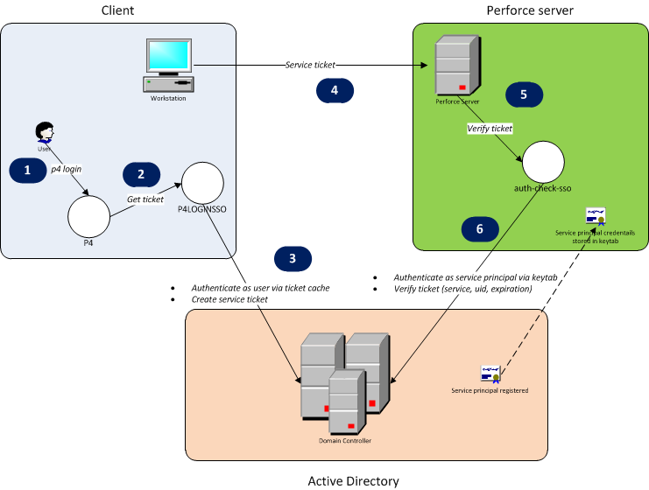
Figure 1: SSO Implementation architecture
The solution relies on the Kerberos protocol that is part of Active Directory. When this solution is used, a Perforce login request goes through several steps, as shown in Figure 1.
- The user runs the p4 login command, either directly through the p4 command line client, or through another client program.
- The client program recognizes the presence of the P4LOGINSSO environment variable, and calls the program referenced by P4LOGINSSO to obtain a Kerberos ticket-granting ticket.
- The P4LOGINSSO program authenticates to Active Directory as the current user by accessing the Kerberos ticket cache. It then creates a ticket-granting ticket for the Kerberos service used by Perforce.
- The ticket is returned to the client program and passed to the Perforce server.
- The Perforce server executes the auth-check-sso trigger to verify the ticket.
- The auth-check-sso trigger authenticates itself as the Perforce service principal to Active Directory. It then verifies that the user’s ticket is valid.
As the diagram indicates, the Perforce service principal’s credentials must be stored on the Perforce server machine in the keytab file.

Implementation
This solution uses Java programs to retrieve and verify a Kerberos service ticket for the Perforce service, using the techniques described at http://www.javaactivedirectory.com. The source code is available, along with an Ant script for building and packaging.

Deploying the solution
The details of deploying this solution will almost certainly vary depending on your environment. Therefore, the instructions below are for reference only.
These instructions reference files described in Appendix 2: File manifest.

Test environment details
These instructions worked in a testing environment consisting of:
- A 32-bit Windows Server 2003 machine serving as the Active Directory domain controller (see Appendix 1: Domain Controller setup notes).
- A 2010.2 Perforce server running on the Windows Server 2003 machine.
- One client workstation running 32-bit Windows XP and the Perforce 2010.2 command line client.
- One client workstation running 64-bit Ubuntu 11 and the Perforce 2010.2 command line client. This workstation used winbind to join the Active Directory domain, as described in https://help.ubuntu.com/community/ActiveDirectoryWinbindHowto.
The following client programs were tested:
- The Perforce command line client, p4, version 2010.2
- P4V, version 2010.2
- P4Eclipse, version 2010.1
- P4SCC, version 2010.2
Of these four clients, p4, P4V, and P4Eclipse let a user authenticate without any password prompt. P4SCC gave a password prompt but authenticated successfully if the password field was left empty.

Client
- If using Windows, make sure that Windows will allow use of ticket-granting tickets. (See http://www.javaactivedirectory.com/?page_id=93.)
- On each client workstation, put the files login.conf, sso-client.jar, and sso-client.[bat|sh] into a directory accessible to the user.
- Modify the login.conf file, keeping only the SignedOnUserLoginContext section.
- Customize the driver script (sso-client.bat for Windows, sso-client.sh for non-Windows). The general format is:
"<path to JDK 6 java>" -jar <path to sso-client.jar> <path to SSO log file> <overwrite SSO log file during each run? true|false> <domain/realm> <domain controller> <path to login.conf> "<fully qualified service principal>"
- Set the P4LOGINSSO environment variable to point to sso-client.bat.

Server
- If using Windows, make sure that Windows will allow use of ticket-granting tickets. (See http://www.javaactivedirectory.com/?page_id=93.)
- On the Perforce server machine, put the files login.conf, sso-server.jar, and sso-server.[bat|sh] into a directory accessible to the account running the Perforce server.
- Customize the ServicePrincipalLoginContext section of login.conf. The general format is:
com.sun.security.auth.module.Krb5LoginModule required useKeyTab=true doNotPrompt=true principal="<fully qualified service principal>" useKeyTab=true doNotPrompt=true storeKey=true keyTab="<path to keytab>";
See Appendix 1: Domain Controller setup notes for a description of how to generate the keytab file.
- Customize the sso-server.bat driver script. The general format is:
"<path to JDK 6 java>" -jar <path to sso-client.jar> <path to SSO log file> <overwrite SSO log file during each run? true|false> <Perforce user ID passed as trigger argument> <domain/realm> <domain controller> <path to login.conf> "<fully qualified service principal>"
- Install the trigger:
  - Run p4 triggers.
  - Add an entry similar to: sso auth-check-sso auth "<path to sso-server.bat> %user%"
  - Restart the Perforce server.

Usage
Once the SSO solution is in place, a Perforce user will not have to supply a password when logging in, although command line users will need to run p4 login.

Appendix 1: Domain Controller setup notes
This section is not a comprehensive description of how to configure an Active Directory domain controller. Rather, it describes particular steps that may be of interest.
As a general approach, the steps described at at http://d3planet.com/rtfb/2009/08/26/building-an-active-directory-domain-controller-for-development-using-vmware-workstation-pt-2/ were used to configure the domain controller for a test environment.
- The domain controller required a recent version of Windows Support Tools. For Windows Server 2003, the Support Tools are available from http://www.microsoft.com/downloads/details.aspx?FamilyID=96a35011-fd83-419d-939b-9a772ea2df90.
- The domain controller required a patch for a Kerberos encryption bug (Microsoft KB#833708).
- When configuring the service principal account, the Use DES encryption option must be selected immediately after creating the account. Otherwise, the password must be reset after this option is selected.
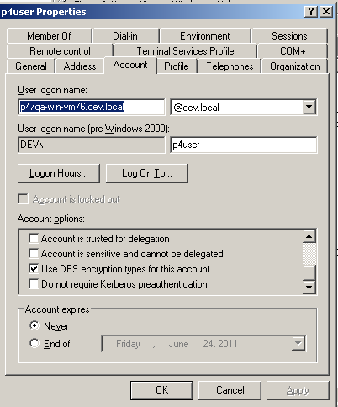
Figure 2: DES encryption option
- When registering the service principal account on the Perforce server machine, the keytab file was created using ktpass. For example, in a testing environment, using p4user as the service principal account for the p4 service, in a domain called DEV.LOCAL:
ktpass -princ p4/domain-controller.dev.local@DEV.LOCAL -ptype KRB5_NT_PRINCIPAL -crypto DES-CBC-CRC -mapuser "p4user" -pass * -out c:\keytab -kvno 0
The keytab file is then used on the Perforce server, and is referenced in login.conf.
- The p4user account was linked to the p4 service using setspn:
setspn -a p4/domain-controller.dev.local@DEV.LOCAL p4user

Appendix 2: File manifest
Apache-license.txt | Apache Software Foundation license
Java\KerbClient | Java source code and JAR file for client side program
Java\KerbServer | Java source code and JAR file for server side trigger
Java\login.conf | Login.conf file used on both client and server
Java\sso-client.bat | Batch file used to run the client Java program as the P4LOGINSSO program on Windows
Java\sso-client.sh | Shell script used to run the client Java program as the P4LOGINSSO program on non-Windows platforms
Java\sso-server.bat | Batch file used as the auth-check-sso trigger
Java\build.xml | Ant script used for building and packaging the Java code. Depends on log4j and commons-codec Apache libraries.

Appendix 3: FAQ
Question | Answer
Why write this solution in Java? | Java has well-structured and documented Kerberos libraries. The same Java programs can be used on multiple platforms.
How much can Perforce support me if I have problems implementing this solution in my environment? | Perforce technical support can provide assistance with Perforce’s SSO mechanism. Unofficial assistance may be available for the Java programs. Detailed assistance with Active Directory problems may be outside the scope of Perforce’s ability to help.
What happens if a client doesn’t set the P4LOGINSSO variable? | They will fall back to regular authentication. You may wish to provide an auth-check trigger so that they can still provide their Active Directory password.
What happens if Active Directory is down? | A client can unset P4LOGINSSO and fall back to regular password authentication. If you need to remove the auth-check-sso trigger on the server and are locked out of Perforce, consult http://kb.perforce.com/article/838/regaining-super-user-access-to-your-perforce-database and http://kb.perforce.com/article/834/p4d-xf-flag.

